**Installing Defender endpoint in Ubuntu systems(16.04,18.04 and 20.04**

Before we start installing and configure Windows defender,please ensure the update is installed

Update the current version – Using software updater

1. Click on Software updater

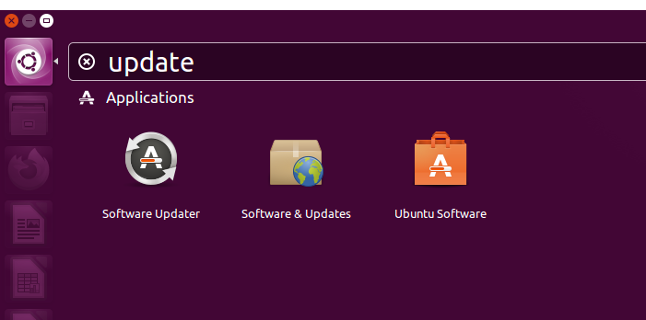

1. Click on settings

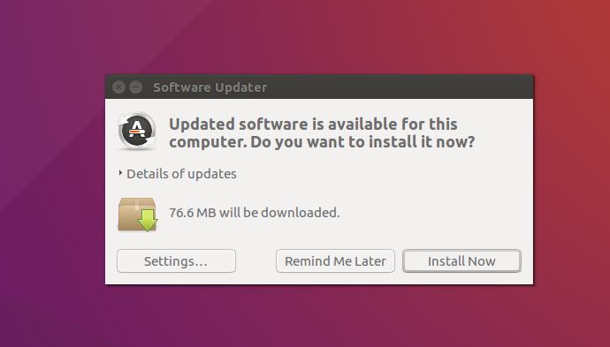

1. Make sure the settings is as per below

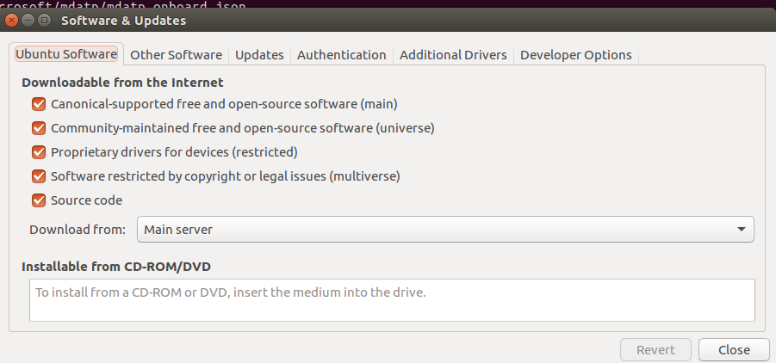

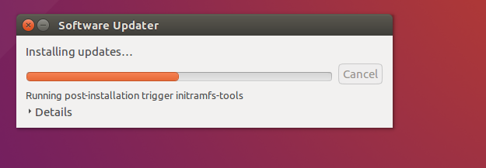

**Configure the Linux software repository**

Defender for Endpoint on Linux can be deployed from one of the following channels (denoted below as *[channel]*): *insiders-fast*, *insiders-slow*, or *prod*. Each of these channels corresponds to a Linux software repository. Instructions for configuring your device to use one of these repositories are provided below.

The choice of the channel determines the type and frequency of updates that are offered to your device. Devices in *insiders-fast* are the first ones to receive updates and new features, followed later by *insiders-slow* and lastly by *prod*.

Note :Here for example we use “prod” as the channel for reference

Steps to install MDATP is mentioned as below

Open terminal and copy the below commands

**Install Curl – Curl is command line tool to transfer data in Linux**

*sudo apt-get install curl*

**Install libplist-utils**

sudo apt-get install libplist-utils

**Update the repository for installing MDATP**

*curl -o microsoft.list https://packages.microsoft.com/config****/[distro]/[version]/[channel]****.list*

(in the above command, depends on the ubuntu version – changes need to be made on the highlighted side

For example, if you are running Ubuntu 18.04 and wish to deploy Microsoft Defender for Endpoint on Linux from the prod channel)

*curl -o microsoft.list https://packages.microsoft.com/config/ubuntu/20.04/prod.list*

**Install the repository configuration:**

*sudo mv ./microsoft.list /etc/apt/sources.list.d/microsoft-prod.list*

**Install the gpg package if not already installed:**

*sudo apt-get install gpg* (For 18.04 and above)

*sudo apt-get install gnupg* (For 16.04)

**Install the Microsoft GPG public key:**

*curl https://packages.microsoft.com/keys/microsoft.asc | sudo apt-key add -*

**Install the https driver if it's not already present:**

sudo apt-get install apt-transport-https

**Update the repository metadata:**

sudo apt-get update

## Application installation

## Ubuntu and Debian system:

sudo apt-get install mdatp - Install application

sudo gedit /etc/apt/sources.list.d/* - open config file in notepad

Above command opens as below -

Replace the file with below data and save and close the file– image as below

deb [arch=arm64,armhf,amd64] https://packages.microsoft.com/config/ubuntu/18.04/prod insiders-fast main

deb [arch=amd64] https://packages.microsoft.com/config/ubuntu/18.04/prod bionic main

sudo apt -t bionic install mdatp - This will be changed based on version

16.04 – xenial

18.04 – Bionic

20.04 –

## Download the onboarding package

Download the onboarding package from Microsoft 365 Defender portal and save it in the ubuntu desktop as below

Right click and open a new terminal as below and paste the below command

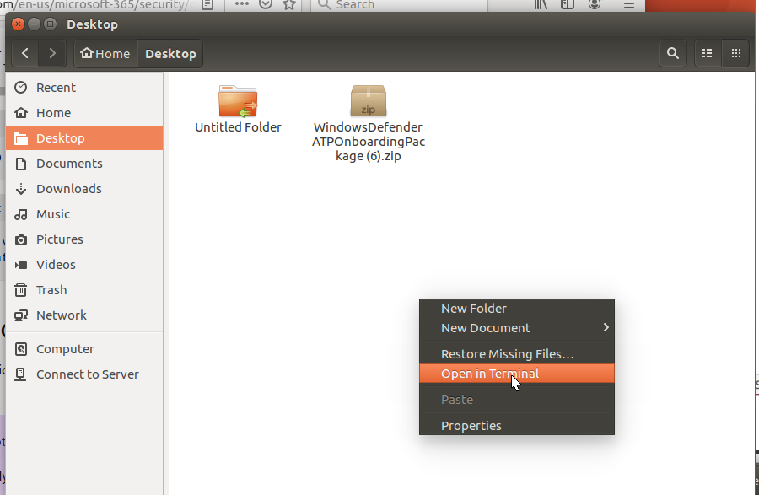

*unzip WindowsDefenderATPOnboardingPackage.zip*

Output of the command

Archive: WindowsDefenderATPOnboardingPackage.zip

inflating: MicrosoftDefenderATPOnboardingLinuxServer.py

## Client configuration

*mdatp health --field org_id*

*sudo python3 MicrosoftDefenderATPOnboardingLinuxServer.py* (20.04)

*sudo python MicrosoftDefenderATPOnboardingLinuxServer.py* (16.04 and 18.04)

*mdatp health --field org_id* Output will be an ID

*mdatp health --field healthy*

*mdatp health --field real_time_protection_enabled*